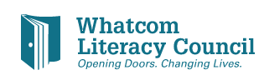Board Alumni Questionnaire
You served - You mattered - You Still Matter!!
Please check the ways you would like to stay in touch with literacy goals in our community:
__ Become a one-on-one tutor or help with a class.
__ Encourage friends to volunteer and become involved with WLC.
__ Attend the annual Trivia Bee in April- bring a friend!
__ Attend the annual Literacy Breakfast in November with your friends- put together a table!
__ Volunteer to help with an event committee.
__ Volunteer your professional expertise for a project.
__ Recommend a future Board member.
__ Meet with the Executive Director or a current board member to discuss ideas. Be a “sounding board” for activities the current board is considering!
__ Offer financial support/donation.
__ Other.

A WLC staff person will contact you regarding the topics you have checked.
THANK YOU for your consideration to help, support, and stayed connected !

Name (please print): ________________________________________________________
Best way to contact you:
_____________________________________________________________________________

